Министерство образования и молодежной политики Свердловской области



ГАПОУ СО «Екатеринбургский колледж транспортного строительства»

Отчёт по программе «**Задание 6.2 Вариант 4**»

Выполнил: ФИО

Группа: ПР-21

Преподаватель: Мирошниченко Г.В

2023

**Задание:**

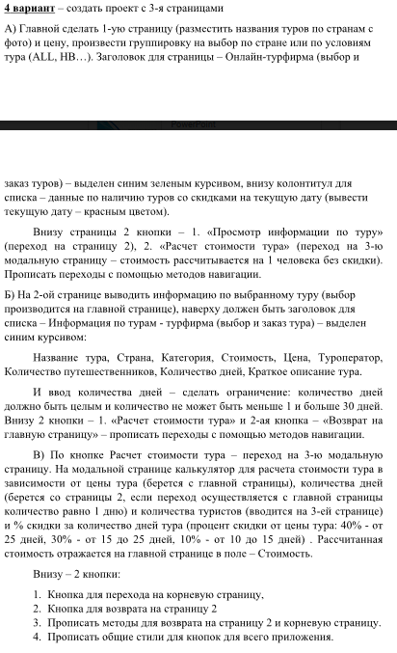

**Листинг программы (если есть)**

|  |
| --- |
| public partial class MainPage : ContentPage  {  public ObservableCollection<GroupTour<string, Tour>> TourGroups { get; set; }  List<Tour> obTour;  List<HotTour> obhotTour;  Tour item = new Tour();  HotTour item_hot = new HotTour();  public MainPage()  {  InitializeComponent();  item = null;  item_hot = null;  AddTour();  AddHotTour();  HottourList.ItemsSource = obhotTour;  }  public void AddTour()  {  try  {  obTour = new List<Tour>  {  new Tour {tourImage ="https://attaches.1001tur.ru/hotels/gallery/476942/95641498163445.jpg", tourName="Гостиница Эдельвейс ",tourCountry="Анапа", tourDetalst="Этот круглогодичный отель расположен на берегу Чёрного моря.", tourPrice="7586", tourTouroperator="Tutu" },  new Tour { tourImage = "https://cdn2.tu-tu.ru/image/tours_hotel_full/1/0131aa48f20ec46445c4ef72ce9aa136/", tourName = "Туры в отель Bin Billa Hotel", tourCountry = "Турция", tourPrice ="8021", tourDetalst ="Городской отель с русскоговорящим персоналом и анимацией", tourTouroperator="Tutu"},  new Tour { tourImage="https://attaches.1001tur.ru/hotels/gallery/425846/21881620934046.jpg",tourName="Вилла Бавария 3* ",tourCountry="Сочи", tourDetalst="Отель Вилла Бавария расположен в центральном районе города-курорта Сочи", tourPrice = "15200", tourTouroperator="Tutu"},  new Tour { tourImage = "https://cdn2.tu-tu.ru/image/tours_hotel_full/1/e45e3842b400e40fe72c87254afa2d14/", tourName = "Туры в отель Bariscan", tourCountry = "Турция", tourDetalst="Небольшой уютный отель для семейного отдыха на побережье", tourPrice="16421", tourTouroperator="Tutu"}  };  var groups = obTour.GroupBy(p => p.tourCountry).Select(g => new GroupTour<string, Tour>(g.Key, g));  TourGroups = new ObservableCollection<GroupTour<string, Tour>>(groups);  this.BindingContext = this;  }  catch (Exception ex)  {  }  }  public void AddHotTour()  {  try  {  obhotTour = new List<HotTour>  {  new HotTour { hottourImage = "https://cdn2.tu-tu.ru/image/tours_hotel_full/1/87cf22c6cbd1cddc411840517c870796/",hottourName = "Туры в отель Imeros", hottourCountry = "Турция", hottourDiscont = "1000", tourDetalst="Уютный отель для экономичного отдыха рядом с пляжем", tourPrice="25290", tourTouroperator="Tuty"},  new HotTour { hottourImage = "https://attaches.1001tur.ru/hotels/gallery/476942/95641498163445.jpg",hottourName = "Атлант Sky Отель 3* ", hottourCountry = "Красная поляна", hottourDiscont = "1500",tourDetalst="Отель Атлант Sky располагается в центе курорта Красная Поляна на территории Сочинского заповедника.", tourTouroperator="Tutu", tourPrice="5682"},  };  }  catch (Exception ex)  {  }  }  private async void ToInformationPage(object sender, EventArgs e)  {  if (item == null)  {  if (item_hot == null)  {  await DisplayAlert("Ошибка", "Чтобы посмотреть информацию о туре, выберите тур", "ОК");  }  else  {  await Navigation.PushAsync(new ToutInformationPage(item_hot));  }  }  else  {  await Navigation.PushAsync(new ToutInformationPage(item));  }  }  private async void ToCalculationTour(object sender, EventArgs e)  {  if (item == null)  {  if (item_hot == null)  {  await DisplayAlert("Ошибка", "Чтобы посмотреть информацию о туре, выберите тур", "ОК");  }  else  {  await Navigation.PushAsync(new СalculationTour(item_hot, "1","1"));  }  }  else  {  await Navigation.PushAsync(new СalculationTour(item,"1","1"));  }  }  private void hottourList_ItemSelected(object sender, ItemTappedEventArgs e)  {  var select = (HotTour)e.Item;  DisplayAlert("Вы выбрали тур", $"{select.hottourName}-{select.hottourCountry}", "ОК");  item_hot = (HotTour)e.Item;  }  private void tourList_ItemSelected(object sender, ItemTappedEventArgs e)  {  var select = (Tour)e.Item;  DisplayAlert("Вы выбрали тур", $"{select.tourName}-{select.tourCountry}", "ОК");  item = (Tour)e.Item;  }  } |
| <?xml version="1.0" encoding="utf-8" ?>  <ContentPage xmlns="http://xamarin.com/schemas/2014/forms"  xmlns:x="http://schemas.microsoft.com/winfx/2009/xaml"  x:Class="praktika6_2.MainPage">  <ContentPage.Resources>  <StyleSheet Source="styles.css"/>  </ContentPage.Resources>  <StackLayout>  <ListView x:Name="tourList" HorizontalOptions="StartAndExpand"  VerticalOptions="FillAndExpand" SeparatorColor="LightGray"  ItemTapped="tourList_ItemSelected"  HasUnevenRows="True" IsGroupingEnabled="True"  GroupDisplayBinding="{Binding Country_group}"  ItemsSource="{Binding TourGroups}">  <ListView.Header>  <Label Text="Онлайн-турфирма" TextColor="Green" FontAttributes="Italic" FontSize="25" HorizontalOptions="FillAndExpand"></Label>  </ListView.Header>  <ListView.ItemTemplate>  <DataTemplate>  <ViewCell>  <StackLayout BackgroundColor ="White" Orientation="Horizontal" Padding="5" VerticalOptions="FillAndExpand"  MinimumHeightRequest="100">  <Image Source="{Binding tourImage}" WidthRequest="70" HeightRequest="70"/>  <StackLayout Orientation="Vertical" Padding="2" VerticalOptions="Center">  <Label Text="{Binding tourName}" FontSize="20" Margin="2" TextColor="Black" />  <Label Text="{Binding tourCountry}" FontSize="16" Margin="4,-5,0,0" TextColor="Black"/>  </StackLayout>  </StackLayout>  </ViewCell>  </DataTemplate>  </ListView.ItemTemplate>  </ListView>  <ListView x:Name="HottourList" HorizontalOptions="StartAndExpand"  VerticalOptions="FillAndExpand" SeparatorColor="LightGray"  HasUnevenRows="True" ItemTapped="hottourList_ItemSelected">  <ListView.Header>  <Label Text="Горячие онлайн-туры" TextColor="Green" FontAttributes="Italic" FontSize="25" HorizontalOptions="FillAndExpand"></Label>  </ListView.Header>  <ListView.ItemTemplate>  <DataTemplate>  <ViewCell>  <StackLayout BackgroundColor ="White" Orientation="Horizontal" Padding="5" VerticalOptions="FillAndExpand"  MinimumHeightRequest="100">  <Image Source="{Binding hottourImage}" WidthRequest="70" HeightRequest="70"/>  <StackLayout Orientation="Vertical" Padding="2" VerticalOptions="Center">  <Label Text="{Binding hottourName}" FontSize="20" Margin="2" TextColor="Black" />  <StackLayout Orientation="Horizontal" Padding="2" VerticalOptions="Center">  <Label Text="{Binding hottourCountry}" FontSize="16" HorizontalOptions="End" TextColor="Black"/>  </StackLayout>  </StackLayout>  </StackLayout>  </ViewCell>  </DataTemplate>  </ListView.ItemTemplate>  </ListView>  <StackLayout Orientation="Horizontal" StyleId="contentpage" Margin="0,-150,0,0">  <Button x:Name="button1_checktour" StyleId="button" Text="Информация о туре" CommandParameter="{Binding .}" HorizontalOptions="StartAndExpand" Clicked="ToInformationPage"></Button>  <Button x:Name="button1_calculatetour" StyleId="button" HorizontalOptions="EndAndExpand" Text="Расчитать стоимость тура" CommandParameter="{Binding .}" Clicked="ToCalculationTour"></Button>  </StackLayout>  </StackLayout>  </ContentPage> |
|  |

|  |
| --- |
| sing System;  using System.Collections.Generic;  using System.Linq;  using System.Text;  using System.Threading.Tasks;  using Xamarin.Forms;  using Xamarin.Forms.Xaml;  namespace praktika6_2  {  [XamlCompilation(XamlCompilationOptions.Compile)]  public partial class ToutInformationPage : ContentPage  {  Tour tour_ = new Tour();  HotTour hottour_ = new HotTour();  public ToutInformationPage(Tour tour_select)  {  InitializeComponent();  tour_ = tour_select;  image.Source = tour_select.tourImage;  nameTour.Text = "Название тура: " + tour_select.tourName;  countryTour.Text = "Страна: " + tour_select.tourCountry;  priceTour.Text = "Стоимость 1 ночи: " + tour_select.tourPrice +"р";  touroperatorTour.Text = "Туроператор: " + tour_select.tourTouroperator;  detalsTour.Text = "Детали: " + tour_select.tourDetalst;  }  public ToutInformationPage(HotTour hot_tour_select)  {  InitializeComponent();  hottour_ = hot_tour_select;  image.Source = hot_tour_select.hottourImage;  nameTour.Text = "Название тура: " + hot_tour_select.hottourName;  countryTour.Text = "Страна: " + hot_tour_select.hottourCountry;  priceTour.Text = "Стоимость 1 ночи: " + hot_tour_select.tourPrice + "р" +" "+ hot_tour_select.hottourDiscont + "р";  touroperatorTour.Text = "Туроператор: " + hot_tour_select.tourTouroperator;  detalsTour.Text = "Детали: " + hot_tour_select.tourDetalst;  }  private void button1_checktour_Clicked(object sender, EventArgs e)  {  Navigation.PushAsync(new MainPage());  }  private void button1_calculatetour_Clicked(object sender, EventArgs e)  {  if (entry_days.Text != null && entry_tourist.Text != null)  {  if (tour_ == null)  {  if (hottour_ == null)  {  DisplayAlert("Ошибка", "Чтобы рассчитать стоимость тура, выберите тур", "ОК");  }  else  {  Navigation.PushAsync(new СalculationTour(hottour_, hottour_.tourDays, hottour_.tourTourists));  }  }  else  {  Navigation.PushAsync(new СalculationTour(tour_, $"{tour_.tourDays}", $"{tour_.tourTourists}"));  }  }  else  {  DisplayAlert("Ошибка", "Заполните поля и сохраните данные", "ОК");  }  }  private void button_savedays_Clicked(object sender, EventArgs e)  {  if (tour_ != null)  {  if (entry_days.Text != string.Empty)  {  try  {  int day = Convert.ToInt32(entry_days.Text);  if (day >= 1 && day <= 30)  {  tour_.tourDays = day.ToString();  entry_days.InputTransparent = true;  }  else  {  DisplayAlert("Ошибка", "Недопустимый диапазон значений", "ОК");  entry_days.Text = string.Empty;  }  }  catch  {  DisplayAlert("Ошибка", "Возникло исключение", "ОК");  entry_days.Text = string.Empty;  }  }  else  {  DisplayAlert("Ошибка", "Заполните поле", "ОК");  entry_days.Text = string.Empty;  }  }  else if (hottour_ != null)  {  if (entry_days.Text != string.Empty)  {  try  {  int day = Convert.ToInt32(entry_days.Text);  if (day >= 1 && day <= 30)  {  hottour_.tourDays = day.ToString();  entry_days.InputTransparent = true;  }  else  {  DisplayAlert("Ошибка", "Недопустимый диапазон значений", "ОК");  entry_days.Text = string.Empty;  }  }  catch  {  DisplayAlert("Ошибка", "Возникло исключение", "ОК");  entry_days.Text = string.Empty;  }  }  else  {  DisplayAlert("Ошибка", "Заполните поле", "ОК");  entry_days.Text = string.Empty;  }  }  }  private void button_savetourist_Clicked(object sender, EventArgs e)  {  if (tour_ != null)  {  if (entry_tourist.Text != string.Empty)  {  try  {  int tourist = Convert.ToInt32(entry_tourist.Text);  if (tourist >= 1 && tourist <= 6)  {  tour_.tourTourists = tourist.ToString();  entry_tourist.InputTransparent = true;  }  else  {  DisplayAlert("Ошибка", "Недопустимый диапазон значений", "ОК");  entry_tourist.Text = string.Empty;  }  }  catch  {  DisplayAlert("Ошибка", "Возникло исключение", "ОК");  entry_tourist.Text = string.Empty;  }  }  else  {  DisplayAlert("Ошибка", "Заполните поле", "ОК");  entry_tourist.Text = string.Empty;  }  }  else if (hottour_ != null)  {  if (entry_tourist.Text != string.Empty)  {  try  {  int tourist = Convert.ToInt32(entry_tourist.Text);  if (tourist >= 1 && tourist <= 5)  {  hottour_.tourTourists = tourist.ToString();  entry_tourist.InputTransparent = true;  }  else  {  DisplayAlert("Ошибка", "Недопустимый диапазон значений", "ОК");  entry_tourist.Text = string.Empty;  }  }  catch  {  DisplayAlert("Ошибка", "Возникло исключение", "ОК");  entry_tourist.Text = string.Empty;  }  }  else  {  DisplayAlert("Ошибка", "Заполните поле", "ОК");  entry_tourist.Text = string.Empty;  }  }  }  }  } |
| <?xml version="1.0" encoding="utf-8" ?>  <ContentPage xmlns="http://xamarin.com/schemas/2014/forms"  xmlns:x="http://schemas.microsoft.com/winfx/2009/xaml"  x:Class="praktika6_2.ToutInformationPage">  <ContentPage.Resources>  <StyleSheet Source="styles.css"/>  </ContentPage.Resources>  <StackLayout Orientation="Vertical" >  <Label Text="Информация о туре" TextColor="Blue" FontAttributes="Italic" FontSize="25" HorizontalOptions="FillAndExpand"></Label>  <Image x:Name="image" WidthRequest="200" HeightRequest="180" HorizontalOptions="Center"></Image>  <Label x:Name="nameTour" Text="Название тура:" Margin="0,0,0,0" FontSize="17" TextColor="Black"></Label>  <Label x:Name="countryTour" Text="Страна:" Margin="0,10,0,0" FontSize="17" TextColor="Black"></Label>  <Label x:Name="priceTour" Text="Стоимость 1 ночи:" Margin="0,10,0,0" FontSize="17" TextColor="Black"></Label>  <Label x:Name="touroperatorTour" Text="Туроператор:" Margin="0,10,0,0" FontSize="17" TextColor="Black"></Label>  <Label x:Name="detalsTour" Text="Детали:" Margin="0,10,0,0" FontSize="17" TextColor="Black"></Label>  <StackLayout Orientation="Horizontal">  <Label x:Name="touristTour" Text="Количество туристов:" Margin="0,10,0,0" FontSize="17" TextColor="Black"></Label>  <Entry x:Name="entry_tourist" WidthRequest="185" StyleId="entry"></Entry>  <Button x:Name="button_savetourist" WidthRequest="30" HeightRequest="10" Clicked="button_savetourist_Clicked"></Button>  </StackLayout>  <StackLayout Orientation="Horizontal">  <Label x:Name="daysTour" Text="Количество дней:" Margin="0,10,0,0" FontSize="17" TextColor="Black"></Label>  <Entry x:Name="entry_days" WidthRequest="218" StyleId="entry"></Entry>  <Button x:Name="button_savedays" WidthRequest="30" HeightRequest="10" Clicked="button_savedays_Clicked"></Button>  </StackLayout>  <StackLayout Orientation="Horizontal" StyleId="contentpage" Margin="0,25,0,0">  <Button x:Name="button1_checktour" Clicked="button1_checktour_Clicked" StyleId="button" Text="На главную страницу" CommandParameter="{Binding .}" HorizontalOptions="StartAndExpand" ></Button>  <Button x:Name="button1_calculatetour" Clicked="button1_calculatetour_Clicked" StyleId="button" HorizontalOptions="End" Text="Расчитать стоимость тура" CommandParameter="{Binding .}" ></Button>  </StackLayout>  </StackLayout>  </ContentPage> |
|  |

|  |
| --- |
| using System;  using System.Collections.Generic;  using System.Linq;  using System.Text;  using System.Threading.Tasks;  using Xamarin.Forms;  using Xamarin.Forms.Xaml;  namespace praktika6_2  {  [XamlCompilation(XamlCompilationOptions.Compile)]  public partial class СalculationTour : ContentPage  {  Tour tour_ = new Tour();  HotTour hottour_ = new HotTour();  public СalculationTour (Tour tour_select, string day, string tourist)  {  InitializeComponent ();  tour_ = null;  tour_ = tour_select;  tour_.tourTourists = tourist;  tour_.tourDays = day;  nameTour.Text = "Название тура: " + tour_.tourName;  countryTour.Text = "Страна: " + tour_.tourCountry;  priceTour.Text = "Стоимость 1 ночи: " + tour_.tourPrice + "р";  touristTour.Text = "Туристов: " + tour_.tourTourists;  dayTour.Text = "Дней: " + tour_.tourDays;  int day_count = Convert.ToInt32(tour_.tourDays);  if (day_count >= 10 && day_count <= 15)  {  tour_.tourDiscont = "0.1";  discontTour.Text = "Скидка: " + "10%";  }  else if (day_count >=15 && day_count<=25)  {  tour_.tourDiscont = "0.3";  discontTour.Text = "Скидка: " + "30%";  }  else if (day_count>=25 && day_count<=30)  {  tour_.tourDiscont = "0.4";  discontTour.Text = "Скидка: " + "40%";  }  else  {  tour_.tourDiscont = "1";  discontTour.Text = "Скидок нет";  }  }  public СalculationTour(HotTour hottour_select, string day, string tourist)  {  InitializeComponent();  tour_ = null;  hottour_ = hottour_select;  hottour_.tourTourists = tourist;  hottour_.tourDays = day;  nameTour.Text = "Название тура: " + hottour_.hottourName;  countryTour.Text = "Страна: " + hottour_.hottourCountry;  priceTour.Text = "Стоимость 1 ночи: " + hottour_.tourPrice + "р -" + Convert.ToInt32(hottour_.hottourDiscont) * Convert.ToInt32(tourist); ;  touristTour.Text = "Туристов: " + hottour_.tourTourists;  dayTour.Text = "Дней: " + hottour_.tourDays;  int day_count = Convert.ToInt32(hottour_.tourDays);  if (day_count >= 10 && day_count <= 15)  {  hottour_.hottourDiscont2 = "0.1";  discontTour.Text = "Скидка: " + "10%" + "-" + Convert.ToInt32(hottour_select.hottourDiscont) * Convert.ToInt32(tourist);  }  else if (day_count >= 15 && day_count <= 25)  {  hottour_.hottourDiscont2 = "0.3";  discontTour.Text = "Скидка: " + "30%" + "-" + Convert.ToInt32(hottour_select.hottourDiscont) * Convert.ToInt32(tourist);  }  else if (day_count >= 25 && day_count <= 30)  {  hottour_.hottourDiscont2 = "0.4";  discontTour.Text = "Скидка: " + "40%" + "-" + Convert.ToInt32(hottour_select.hottourDiscont) * Convert.ToInt32(tourist);  }  else if (day_count >=1 && day_count<=9)  {  hottour_.hottourDiscont2 = "1";  discontTour.Text = "Скидок нет";  }  }  private void button3_checktour_Clicked(object sender, EventArgs e)  {  Navigation.PushAsync(new MainPage());  }  private void button3_calculatetour_Clicked(object sender, EventArgs e)  {  if (tour_ != null)  {  Navigation.PushAsync(new ToutInformationPage(tour_));  }  else  {  Navigation.PushAsync(new ToutInformationPage(hottour_));  }  }  private void button3_Calculate_Clicked(object sender, EventArgs e)  {  if (tour_ != null)  {  double tour_discont_price = 0 ;  double tourprice_w = 0;  if (tour_.tourDiscont == "1")  {  tour_discont_price = 0;  }  else  {  tourprice_w = Convert.ToInt32(tour_.tourPrice) * Convert.ToInt32(tour_.tourDays) * Convert.ToInt32(tour_.tourTourists);  tour_discont_price = tourprice_w * Convert.ToDouble(tour_.tourDiscont);  }  tourprice_w = Convert.ToInt32(tour_.tourPrice) * Convert.ToInt32(tour_.tourDays) * Convert.ToInt32(tour_.tourTourists);  double price = tourprice_w - tour_discont_price;  price_lable.Text = "Стоимость тура c учетом скидок: " + price;  }  else if (hottour_ != null)  {  double hottour_discont2_price=0;  double tourprice_w = 0;  if (hottour_.hottourDiscont2 == "1")  {  hottour_discont2_price = 0;  }  else  {  tourprice_w = Convert.ToInt32(hottour_.tourPrice) * Convert.ToInt32(hottour_.tourDays) * Convert.ToInt32(hottour_.tourTourists);  hottour_discont2_price = tourprice_w * Convert.ToInt32(hottour_.hottourDiscont2);  }  double hottour_discont_price = Convert.ToInt32(hottour_.hottourDiscont) * Convert.ToInt32(hottour_.tourTourists);  tourprice_w = Convert.ToInt32(hottour_.tourPrice) * Convert.ToInt32(hottour_.tourDays) * Convert.ToInt32(hottour_.tourTourists);  double price = tourprice_w - hottour_discont2_price - hottour_discont_price;  price_lable.Text = "Стоимость тура c учетом скидок: " + price;  }  }  }  } |
| <?xml version="1.0" encoding="utf-8" ?>  <ContentPage xmlns="http://xamarin.com/schemas/2014/forms"  xmlns:x="http://schemas.microsoft.com/winfx/2009/xaml"  x:Class="praktika6_2.СalculationTour">  <ContentPage.Resources>  <StyleSheet Source="styles.css"/>  </ContentPage.Resources>  <StackLayout Orientation="Vertical" >  <Label Text="Расчет стоимости тура" TextColor="Blue" FontAttributes="Italic" FontSize="25"></Label>  <Label x:Name="nameTour" Text="Название тура:" Margin="0,0,0,0" FontSize="17" TextColor="Black"></Label>  <Label x:Name="countryTour" Text="Страна:" Margin="0,10,0,0" FontSize="17" TextColor="Black"></Label>  <Label x:Name="priceTour" Text="Стоимость 1 ночи:" Margin="0,10,0,0" FontSize="17" TextColor="Black"></Label>  <Label x:Name="dayTour" Text="Дней:" Margin="0,10,0,0" FontSize="17" TextColor="Black"></Label>  <Label x:Name="touristTour" Text="Туристов:" Margin="0,10,0,0" FontSize="17" TextColor="Black"></Label>  <Label x:Name="discontTour" Text="Скидка:" Margin="0,10,0,0" FontSize="17" TextColor="Black"></Label>  <Button x:Name="button3_Calculate" StyleId="button" Text="Рассчитать" HorizontalOptions="StartAndExpand" Clicked="button3_Calculate_Clicked" ></Button>  <Label x:Name="price_lable" Text="Стоимость тура:" Margin="0,10,0,0" FontSize="17" TextColor="Black"></Label>  <StackLayout Orientation="Horizontal" StyleId="contentpage" Margin="0,200,0,0">  <Button x:Name="button3_checktour" StyleId="button" Text="На главную страницу" HorizontalOptions="StartAndExpand" Clicked="button3_checktour_Clicked" ></Button>  <Button x:Name="button3_calculatetour" StyleId="button" HorizontalOptions="End" Text="Просмотр информации" Clicked="button3_calculatetour_Clicked" CommandParameter="{Binding .}" ></Button>  </StackLayout>  </StackLayout>  </ContentPage> |
|  |

|  |
| --- |
| namespace praktika6_2  {  public class Tour  {  public string tourName { get; set; }  public string tourCountry { get; set; }  public string tourImage { get; set; }  public string tourPrice { get; set; }  public string tourTouroperator { get; set; }  public string tourTourists { get; set; }  public string tourDays { get; set; }  public string tourDetalst { get; set; }  public string tourDiscont { get; set; }  }  } |
| namespace praktika6_2  {  public class HotTour  {  public string hottourName { get; set; }  public string hottourCountry { get; set; }  public string hottourImage { get; set; }  public string hottourDiscont { get; set; }  public string hottourDiscont2 { get; set; }  public string tourPrice { get; set; }  public string tourTouroperator { get; set; }  public string tourTourists { get; set; }  public string tourDays { get; set; }  public string tourDetalst { get; set; }  }  } |
| namespace praktika6_2  {  public class GroupTour<K,T>: ObservableCollection<T>  {  public K Country_group {get;set;}  public GroupTour(K country, IEnumerable<T> items)  {  Country_group = country;  foreach(T item in items)  {  Items.Add(item);  }  }  }  } |

**Блок схема**

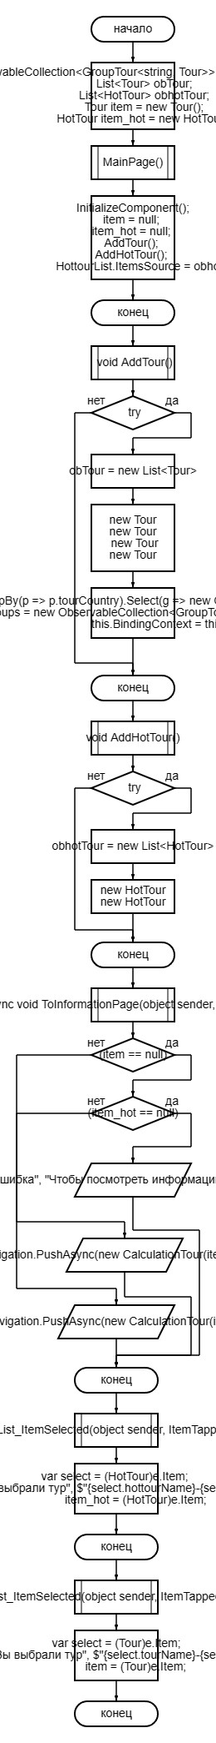

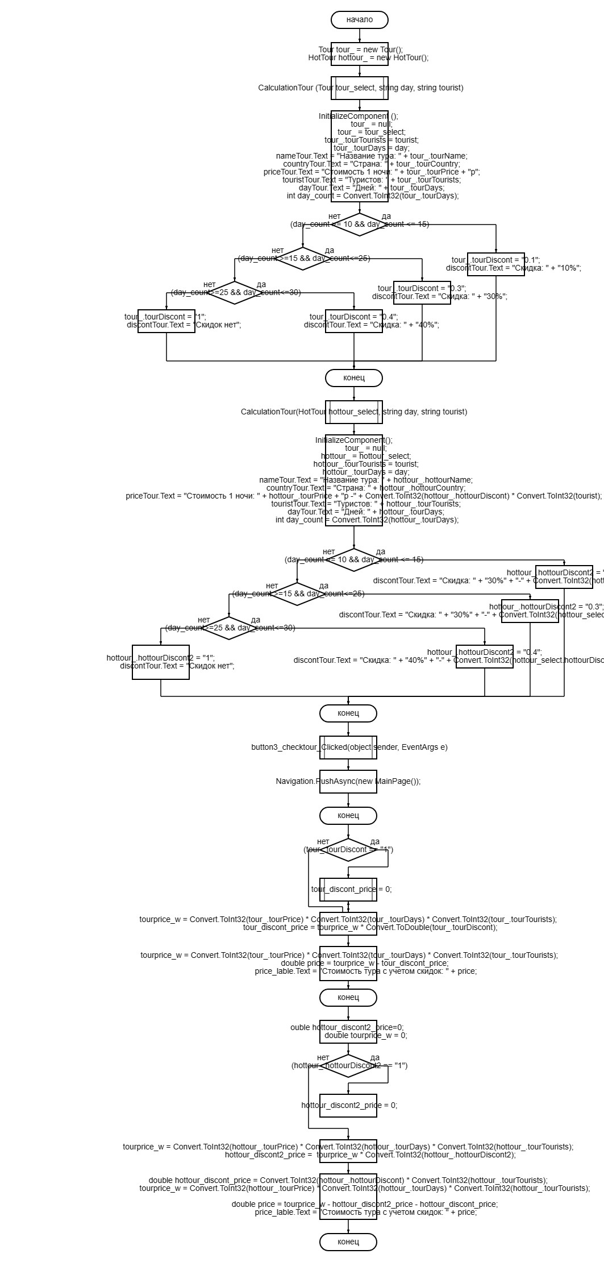

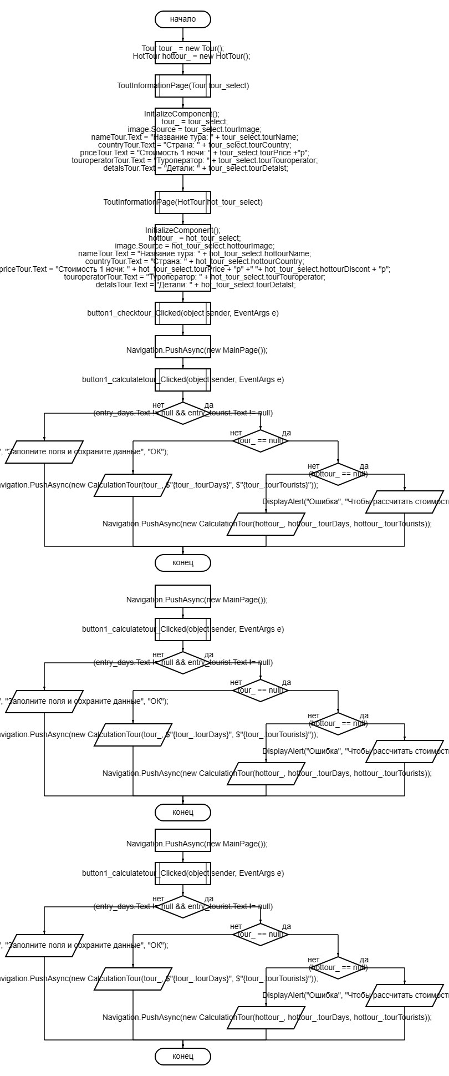

**Тестовые ситуации**



